**SOURCE CODE**

1. **SQL QUERY**
2. CREATE DATABASE Rain_School
3. use Rain_School
4. CREATE TABLE Classes (
5. class_id INT PRIMARY KEY,
6. class_name VARCHAR(50) NOT NULL
7. )
8. insert into Classes values (1,'7th'),(2,'8th')
9. CREATE TABLE Subject (
10. subject_id INT PRIMARY KEY,
11. subject_name VARCHAR(50) NOT NULL,
12. class_id INT,
13. FOREIGN KEY (class_id) REFERENCES Classes (class_id)
14. )
15. insert into Subject values (1,'Science',2),(2,'Mathematics',1)
16. CREATE TABLE Student (
17. student_id INT PRIMARY KEY,
18. student_name VARCHAR(50) NOT NULL,
19. class_id INT,
20. subject_id INT,
21. FOREIGN KEY (class_id) REFERENCES Classes (class_id),
22. FOREIGN KEY (subject_id) REFERENCES Subject (subject_id)
23. )
24. insert into Student values (1,'paul',2,1),(2,'kiran',1,2)
25. select * from Student

**2. Visual studio 2022**

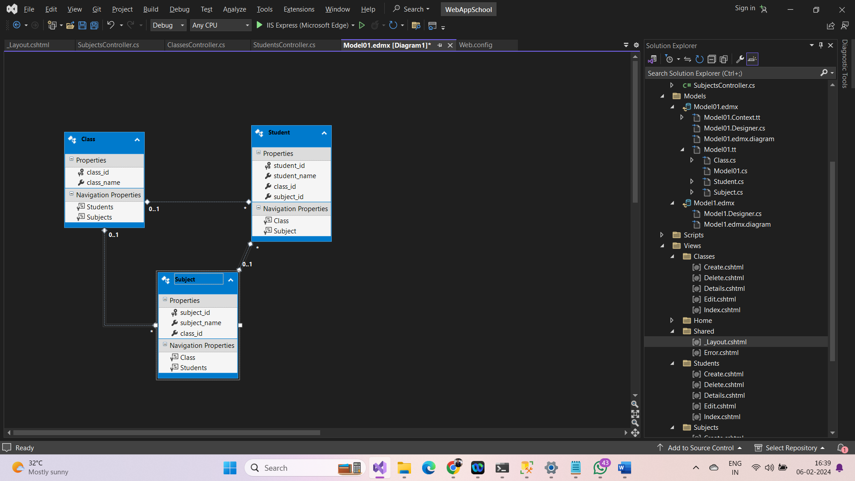

**3. ClassesController.cs (CODE)**

using System;

using System.Collections.Generic;

using System.Data;

using System.Data.Entity;

using System.Linq;

using System.Net;

using System.Web;

using System.Web.Mvc;

using WebAppSchool.Models;

namespace WebAppSchool.Controllers

{

public class ClassesController : Controller

{

private Rain_SchoolEntities1 db = new Rain_SchoolEntities1();

// GET: Classes

public ActionResult Index()

{

return View(db.Classes.ToList());

}

// GET: Classes/Details/5

public ActionResult Details(int? id)

{

if (id == null)

{

return new HttpStatusCodeResult(HttpStatusCode.BadRequest);

}

Class @class = db.Classes.Find(id);

if (@class == null)

{

return HttpNotFound();

}

return View(@class);

}

// GET: Classes/Create

public ActionResult Create()

{

return View();

}

// POST: Classes/Create

// To protect from overposting attacks, enable the specific properties you want to bind to, for

// more details see https://go.microsoft.com/fwlink/?LinkId=317598.

[HttpPost]

[ValidateAntiForgeryToken]

public ActionResult Create([Bind(Include = "class_id,class_name")] Class @class)

{

if (ModelState.IsValid)

{

db.Classes.Add(@class);

db.SaveChanges();

return RedirectToAction("Index");

}

return View(@class);

}

// GET: Classes/Edit/5

public ActionResult Edit(int? id)

{

if (id == null)

{

return new HttpStatusCodeResult(HttpStatusCode.BadRequest);

}

Class @class = db.Classes.Find(id);

if (@class == null)

{

return HttpNotFound();

}

return View(@class);

}

// POST: Classes/Edit/5

// To protect from overposting attacks, enable the specific properties you want to bind to, for

// more details see https://go.microsoft.com/fwlink/?LinkId=317598.

[HttpPost]

[ValidateAntiForgeryToken]

public ActionResult Edit([Bind(Include = "class_id,class_name")] Class @class)

{

if (ModelState.IsValid)

{

db.Entry(@class).State = EntityState.Modified;

db.SaveChanges();

return RedirectToAction("Index");

}

return View(@class);

}

// GET: Classes/Delete/5

public ActionResult Delete(int? id)

{

if (id == null)

{

return new HttpStatusCodeResult(HttpStatusCode.BadRequest);

}

Class @class = db.Classes.Find(id);

if (@class == null)

{

return HttpNotFound();

}

return View(@class);

}

// POST: Classes/Delete/5

[HttpPost, ActionName("Delete")]

[ValidateAntiForgeryToken]

public ActionResult DeleteConfirmed(int id)

{

Class @class = db.Classes.Find(id);

db.Classes.Remove(@class);

db.SaveChanges();

return RedirectToAction("Index");

}

protected override void Dispose(bool disposing)

{

if (disposing)

{

db.Dispose();

}

base.Dispose(disposing);

}

}

}

**4. SubjectsController.cs (CODE)**

using System;

using System.Collections.Generic;

using System.Data;

using System.Data.Entity;

using System.Linq;

using System.Net;

using System.Web;

using System.Web.Mvc;

using WebAppSchool.Models;

namespace WebAppSchool.Controllers

{

public class SubjectsController : Controller

{

private Rain_SchoolEntities1 db = new Rain_SchoolEntities1();

// GET: Subjects

public ActionResult Index()

{

var subjects = db.Subjects.Include(s => s.Class);

return View(subjects.ToList());

}

// GET: Subjects/Details/5

public ActionResult Details(int? id)

{

if (id == null)

{

return new HttpStatusCodeResult(HttpStatusCode.BadRequest);

}

Subject subject = db.Subjects.Find(id);

if (subject == null)

{

return HttpNotFound();

}

return View(subject);

}

// GET: Subjects/Create

public ActionResult Create()

{

ViewBag.class_id = new SelectList(db.Classes, "class_id", "class_name");

return View();

}

// POST: Subjects/Create

// To protect from overposting attacks, enable the specific properties you want to bind to, for

// more details see https://go.microsoft.com/fwlink/?LinkId=317598.

[HttpPost]

[ValidateAntiForgeryToken]

public ActionResult Create([Bind(Include = "subject_id,subject_name,class_id")] Subject subject)

{

if (ModelState.IsValid)

{

db.Subjects.Add(subject);

db.SaveChanges();

return RedirectToAction("Index");

}

ViewBag.class_id = new SelectList(db.Classes, "class_id", "class_name", subject.class_id);

return View(subject);

}

// GET: Subjects/Edit/5

public ActionResult Edit(int? id)

{

if (id == null)

{

return new HttpStatusCodeResult(HttpStatusCode.BadRequest);

}

Subject subject = db.Subjects.Find(id);

if (subject == null)

{

return HttpNotFound();

}

ViewBag.class_id = new SelectList(db.Classes, "class_id", "class_name", subject.class_id);

return View(subject);

}

// POST: Subjects/Edit/5

// To protect from overposting attacks, enable the specific properties you want to bind to, for

// more details see https://go.microsoft.com/fwlink/?LinkId=317598.

[HttpPost]

[ValidateAntiForgeryToken]

public ActionResult Edit([Bind(Include = "subject_id,subject_name,class_id")] Subject subject)

{

if (ModelState.IsValid)

{

db.Entry(subject).State = EntityState.Modified;

db.SaveChanges();

return RedirectToAction("Index");

}

ViewBag.class_id = new SelectList(db.Classes, "class_id", "class_name", subject.class_id);

return View(subject);

}

// GET: Subjects/Delete/5

public ActionResult Delete(int? id)

{

if (id == null)

{

return new HttpStatusCodeResult(HttpStatusCode.BadRequest);

}

Subject subject = db.Subjects.Find(id);

if (subject == null)

{

return HttpNotFound();

}

return View(subject);

}

// POST: Subjects/Delete/5

[HttpPost, ActionName("Delete")]

[ValidateAntiForgeryToken]

public ActionResult DeleteConfirmed(int id)

{

Subject subject = db.Subjects.Find(id);

db.Subjects.Remove(subject);

db.SaveChanges();

return RedirectToAction("Index");

}

protected override void Dispose(bool disposing)

{

if (disposing)

{

db.Dispose();

}

base.Dispose(disposing);

}

}

}

**5. StudentsController.cs (CODE)**

using System;

using System.Collections.Generic;

using System.Data;

using System.Data.Entity;

using System.Linq;

using System.Net;

using System.Web;

using System.Web.Mvc;

using WebAppSchool.Models;

namespace WebAppSchool.Controllers

{

public class StudentsController : Controller

{

private Rain_SchoolEntities1 db = new Rain_SchoolEntities1();

// GET: Students

public ActionResult Index()

{

var students = db.Students.Include(s => s.Class).Include(s => s.Subject);

return View(students.ToList());

}

// GET: Students/Details/5

public ActionResult Details(int? id)

{

if (id == null)

{

return new HttpStatusCodeResult(HttpStatusCode.BadRequest);

}

Student student = db.Students.Find(id);

if (student == null)

{

return HttpNotFound();

}

return View(student);

}

// GET: Students/Create

public ActionResult Create()

{

ViewBag.class_id = new SelectList(db.Classes, "class_id", "class_name");

ViewBag.subject_id = new SelectList(db.Subjects, "subject_id", "subject_name");

return View();

}

// POST: Students/Create

// To protect from overposting attacks, enable the specific properties you want to bind to, for

// more details see https://go.microsoft.com/fwlink/?LinkId=317598.

[HttpPost]

[ValidateAntiForgeryToken]

public ActionResult Create([Bind(Include = "student_id,student_name,class_id,subject_id")] Student student)

{

if (ModelState.IsValid)

{

db.Students.Add(student);

db.SaveChanges();

return RedirectToAction("Index");

}

ViewBag.class_id = new SelectList(db.Classes, "class_id", "class_name", student.class_id);

ViewBag.subject_id = new SelectList(db.Subjects, "subject_id", "subject_name", student.subject_id);

return View(student);

}

// GET: Students/Edit/5

public ActionResult Edit(int? id)

{

if (id == null)

{

return new HttpStatusCodeResult(HttpStatusCode.BadRequest);

}

Student student = db.Students.Find(id);

if (student == null)

{

return HttpNotFound();

}

ViewBag.class_id = new SelectList(db.Classes, "class_id", "class_name", student.class_id);

ViewBag.subject_id = new SelectList(db.Subjects, "subject_id", "subject_name", student.subject_id);

return View(student);

}

// POST: Students/Edit/5

// To protect from overposting attacks, enable the specific properties you want to bind to, for

// more details see https://go.microsoft.com/fwlink/?LinkId=317598.

[HttpPost]

[ValidateAntiForgeryToken]

public ActionResult Edit([Bind(Include = "student_id,student_name,class_id,subject_id")] Student student)

{

if (ModelState.IsValid)

{

db.Entry(student).State = EntityState.Modified;

db.SaveChanges();

return RedirectToAction("Index");

}

ViewBag.class_id = new SelectList(db.Classes, "class_id", "class_name", student.class_id);

ViewBag.subject_id = new SelectList(db.Subjects, "subject_id", "subject_name", student.subject_id);

return View(student);

}

// GET: Students/Delete/5

public ActionResult Delete(int? id)

{

if (id == null)

{

return new HttpStatusCodeResult(HttpStatusCode.BadRequest);

}

Student student = db.Students.Find(id);

if (student == null)

{

return HttpNotFound();

}

return View(student);

}

// POST: Students/Delete/5

[HttpPost, ActionName("Delete")]

[ValidateAntiForgeryToken]

public ActionResult DeleteConfirmed(int id)

{

Student student = db.Students.Find(id);

db.Students.Remove(student);

db.SaveChanges();

return RedirectToAction("Index");

}

protected override void Dispose(bool disposing)

{

if (disposing)

{

db.Dispose();

}

base.Dispose(disposing);

}

}

}

**6.** **_Layout.cshtml**

<!DOCTYPE html>

<html>

<head>

<meta charset="utf-8" />

<meta name="viewport" content="width=device-width, initial-scale=1.0">

<title>@ViewBag.Title - My ASP.NET Application</title>

@Styles.Render("~/Content/css")

@Scripts.Render("~/bundles/modernizr")

</head>

<body>

<nav class="navbar navbar-expand-sm navbar-toggleable-sm navbar-dark bg-dark">

<div class="container">

@Html.ActionLink("Application name", "Index", "Home", new { area = "" }, new { @class = "navbar-brand" })

<button type="button" class="navbar-toggler" data-bs-toggle="collapse" data-bs-target=".navbar-collapse" title="Toggle navigation" aria-controls="navbarSupportedContent"

aria-expanded="false" aria-label="Toggle navigation">

<span class="navbar-toggler-icon"></span>

</button>

<div class="collapse navbar-collapse d-sm-inline-flex justify-content-between">

<ul class="navbar-nav flex-grow-1">

<li>@Html.ActionLink("Home", "Index", "Home", new { area = "" }, new { @class = "nav-link" })</li>

<li>@Html.ActionLink("About", "About", "Home", new { area = "" }, new { @class = "nav-link" })</li>

<li>@Html.ActionLink("Contact", "Contact", "Home", new { area = "" }, new { @class = "nav-link" })</li>

<li>@Html.ActionLink("Class", "Index", "Classes", new { area = "" }, new { @class = "nav-link" })</li>

<li>@Html.ActionLink("Subject", "Index", "Subjects", new { area = "" }, new { @class = "nav-link" })</li>

<li>@Html.ActionLink("Student Details", "Index", "Students", new { area = "" }, new { @class = "nav-link" })</li>

</ul>

</div>

</div>

</nav>

<div class="container body-content">

@RenderBody()

<hr />

<footer>

<p>&copy; @DateTime.Now.Year - My ASP.NET Application</p>

</footer>

</div>

@Scripts.Render("~/bundles/jquery")

@Scripts.Render("~/bundles/bootstrap")

@RenderSection("scripts", required: false)

</body>

</html>